Name: _______________________ Class: __________ Date: _______
Instructions: Write answers in the right-hand column. Score: ___________ / 50 marks
Section A—Multiple choice (10 marks)

 | A solution consists of:  - solid particles suspended in water.  - two different solids ground into powder form and mixed.  - one substance dissolved in another.  - bubbles of gas in a liquid. | C | 1
 | An emulsion is:  - a solution in which a liquid is spread throughout another liquid.  - a colloid in which a liquid is spread throughout another liquid but has not dissolved  - a colloid in which a gas is spread throughout a liquid.  - a solution in which a gas is spread throughout a liquid. | b | 1
 | A beaker of some murky, brown river water was left overnight. Next morning, the water was just as murky as before and there was nothing on the bottom of the beaker. The murky water was probably:  A a colloid. B a solution. C a suspension. D a concentration. | A | 1
 | Which type of separation is best suited to removing grains of rice from hot water?  - Distillation.  - Filtration.  - Sieving.  - Centrifuging. | C | 1
 | Chromatography is:  - the mixing of colours to form photographs.  - a process used to separate chrome from a mineral.  - the bonding of colour to a surface, for example on a Smartie®.  - a technique used to separate chemicals from a mixture. | D | 1
 | A student wishes to obtain fresh water from salt water. The best way to do this is by:  A filtration.  B evaporation.  C distillation.  D decanting. | C | 1
 | Iona and Ross were doing an experiment that involved adding potassium sulfate powder to water. They added one teaspoon of potassium sulfate to the water and stirred it, and all the powder dissolved. This means that potassium sulfate:  A is insoluble in water.  B is soluble in water.  C is an unstable substance.  D cannot be identified as soluble or insoluble from the information given. | b | 1
 | Josh and Ahmed added a small amount of copper sulfate powder to water and stirred it. All the powder dissolved. They continued to add copper sulfate to the water until, after the fourth teaspoon, no more copper sulfate would dissolve. Which of the following statements is incorrect?  A Water is the solvent.  B Copper sulfate powder is the solute.  C The mixture of copper sulfate and water forms a suspension.  D When no more copper sulfate powder will dissolve, the mixture is said to be saturated. | c | 1
 | Isabella added three teaspoons of potassium chloride powder to water and stirred it, and all the powder dissolved. As more potassium chloride dissolves in the water, the mixture becomes:  A more concentrated.  B less concentrated.  C dilute.  D more cloudy. | A | 1
 | Potassium sulfate powder was added to water and stirred to dissolve it to form a solution. More potassium sulfate was added until no more would dissolve. Which would be the best technique to get the potassium sulfate back from the solution?  A Filtration.  B Decanting.  C Centrifuging.  D Evaporation. | D | 1

Section B—Short answer (27 marks)

- ` | Define a mixture. | A substance containing two or more pure substances that can be separated | 2
 | Wax is a solid that will not dissolve in water, but wax does dissolve in kerosene. Sugar will dissolve in water but not in kerosene. Kerosene will not dissolve in water.  a Identify the solvent you would use to make a solution containing wax.  b Identify two substances that are insoluble in water  c Identify a substance that is soluble in water | - Kerosene.  - Wax and kerosene  - Sugar | 3
 | Copper sulfate will dissolve in water but chalk will not. You are given a mixture of blue copper sulfate crystals and blue chalk powder, a filter, a funnel and some water. You need to recover the pure copper sulfate. Explain how you would do this. | Add water and stir to dissolve the copper sulfate. Filter the mixture to remove the chalk. Evaporate the water from the copper sulfate solution to recover the copper sulfate crystals. | 3
 | Draw a diagram to show the difference between a dilute and a concentrated solution. | 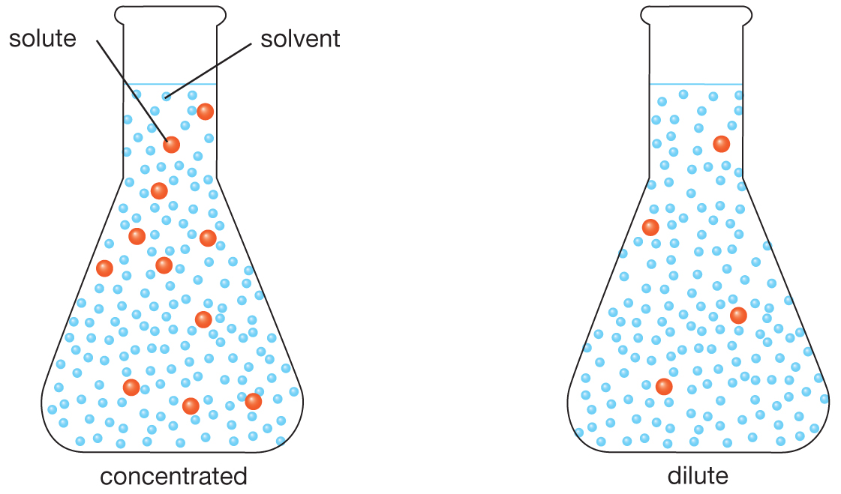 | 4
 | Describe each of the following separation methods and give an example of each  - Magnetic separation.  - Centrifuging.  - Gravity separation.  - Decanting.  - Evaporation. | - A magnet is used to remove magnetic metals from a mixture; for example, an electromagnet used in a scrap metal yard.  - A spinning device (centrifuge) is used to separate heavier particles from lighter particles; for example, cream can be separated from milk using a centrifuge.  - Heavier particles tend to move towards the bottom of a container when the container is shaken; for example, panning for gold.  - A mixture is left to stand so sediment settles on the bottom of the container. The liquid above is then carefully poured into another container; for example, decanting water off cooked vegetables.  - A mixture is boiled and evaporates to leave a solid behind; for example, separating salt from salt water. | 5
 | Contrast distillation and evaporation | Distillation involves evaporation, but in addition the evaporated liquid (called distillate) is allowed to condense and is collected. | 2
 | Describe three ways that filtering or sieving are used in homes. You must name the device used and what it is separating. | Examples:  1 Coffee percolators separate the solid coffee (grounds) from the liquid.  2 A tea strainer separates the tea leaves from the liquid tea.  3 A vacuum cleaner separates dust and dirt from the air sucked in.  4 A colander separates pasta from water.  5 A flour sifter separates lumps from fine flour.  6 An air conditioner filter removes dust from the air.  7 A fuel filter on a car removes dirt from fuel.  8 An air filter in a car removes dirt from air.  9 A washing machine filter removes fluff (lint) from water.  10 A clothes drier filter removes lint from the air.  There may be other examples. | 3
 | Contrast sewage and sewerage. | Sewage is waste water; sewerage is the network of pipes that carries it away. | 2
 | Explain why large amounts of strong disinfectant shouldn’t be flushed into a septic tank system. | The disinfectant might kill the bacteria that break down sewage, causing the tank to fill up more rapidly or produce blockages. | 2
 | The stages in a typical sewage treatment process are: screen, aeration tank, settling tank, pebble filters, UV lamps and outfall.  Identify in which part of the process:  - suspended solids are removed.  - bacteria help break down the sewage.  - bacteria and other solids form a thick sludge. | - pebble filters.  - aeration tank.  - settling tank. | 3

Section C—Thinking scientifically (10 marks)

 | Imagine you are given a blue powder and stir it into water in a beaker. How would you know that the powder had dissolved in the water?  A The powder would settle on the bottom of the beaker and leave the water clear.  B The powder would settle on the bottom of the beaker and leave the water cloudy and coloured.  C The powder would disappear and leave the water clear and coloured.  D The powder would disappear and leave the water cloudy. | C | 1
 | Imagine you have to filter a mixture that contains a very fine, light solid. The solid is so fine that it could block many of the holes in filter paper. The mixture also contains a very heavy insoluble solid. Which of the following would be the best method to separate out all three substances in this mixture?  A Let the mixture stand, then decant (pour off) the liquid, leaving the heavy solid behind. Then filter using fluted filter paper.  B Filter the mixture. Then distil (evaporate then condense) the filtrate to separate out the fine solid.  C Filter the mixture using a conical filter paper, then filter it again using a fluted filter paper.  D Let the mixture stand, then decant the liquid into a fluted filter paper. Then take the filtrate and pass it through a conical filter paper. | D | 1
 | A solution was formed by dissolving 5 g of solid using 250 mL of water. What is the concentration of the solute?  Hint: remember that concentration 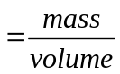  A 0.2 g/mL  B 250 g/mL  C 5 g/mL  D 20 g/mL | A | 1
 | A solution is saturated when no more solute will dissolve in it. A colourless liquid was saturated when 22 g of a blue powder was dissolved in 100 mL of the liquid. To make a solution that was not saturated, which of the following amounts of the powder could you add to 50 mL of the liquid?  A 44 g  B 22 g  C 11 g  D 5 g | D | 1
 | Protective masks used by fire and rescue workers protect them against harmful smoke and fumes at accident sites. They consist of a particle filter, a filter disc and a surface of activated carbon, as shown in the diagram below. Imagine a dangerous fire where there are harmful industrial solvents burning and releasing poisonous gases into the air. How does a mask protect the wearer?  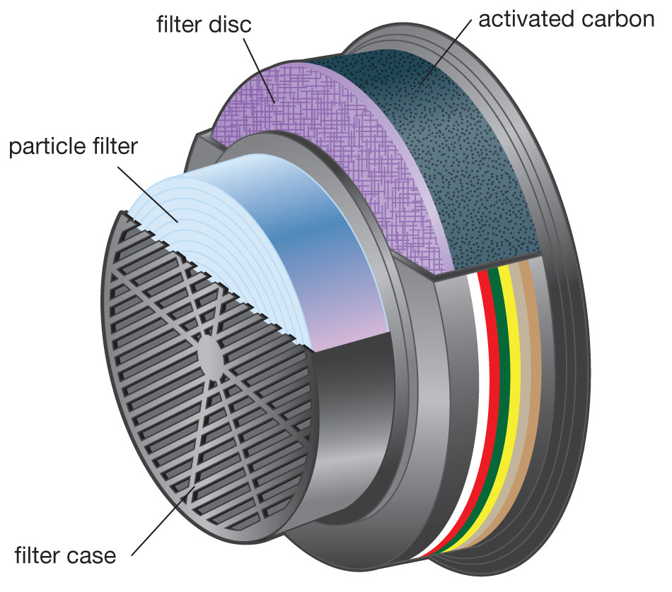  A The fine solid particles in the smoke are filtered out first by the particle filter and filter disc, then the activated carbon removes dangerous gases by adsorbing them onto its surface.  B The particle filter removes dangerous gases by filtering them while the fine solid particles in the smoke are absorbed onto the surface of the activated carbon.  C The activated carbon produces oxygen for the person to breathe.  D Gases are trapped by the particle filter, but the particles pass through this and get filtered out by the activated carbon when they dissolve in it. | A | 1
 | Elaine and Hassan were investigating which substances dissolved in different solvents. Their results are shown in the table below.  Test tube  Solvent  Solute  Observation  1  Water  Calcium carbonate  Insoluble  2  Water  Salt  Soluble  3  Water  Cooking oil  Insoluble  4  Kerosene  Water  Insoluble  5  Kerosene  Cooking oil  Soluble  6  Kerosene  Salt  Insoluble  7  Turpentine  Water  Insoluble  8  Methylated spirits  Water  Soluble  9  Ethanol  Water  Soluble  Which of the following pairs of solvents are able to dissolve water?  A Kerosene and methylated spirits.  B Methylated spirits and turpentine.  C Methylated spirits and ethanol.  D Ethanol and turpentine. | C | 1
 | Using the table in question 6, which of the following solvents is kerosene most like?  A Water.  B Turpentine.  C Methylated spirits.  D Ethanol. | B | 1
 | Sam and Ella were trying to classify four solutions. They were given a table with the examples matched to the wrong type of solution. Help them out by choosing the correct example for each type of solution.  Type of solution  Examples  Solid dissolved in a liquid  1 Oxygen gas in water, oxygen gas in blood  Liquid dissolved in another liquid  2 Oxygen in air, water in air, helium in oxygen  Gas dissolved in a liquid  3 Liquid detergent in water, oil in petrol.  Gas dissolved in another gas  4 Grease dissolved in petrol, sugar in water  Which of the following is the correct order of the examples (going from top to bottom) to match the type of solution in the first column?  A 4, 1, 3, 2  B 3, 4, 2, 1  C 4, 3, 1, 2  D 3, 4, 1, 2 | C | 1
 | Two students wanted to see how much sodium sulfate would dissolve in 100 g of water. After adding three teaspoons of sodium sulfate, no more would dissolve at room temperature (20°C). The students decided to heat the water to dissolve more sodium sulfate. What advice could you give them after looking at the graph below?  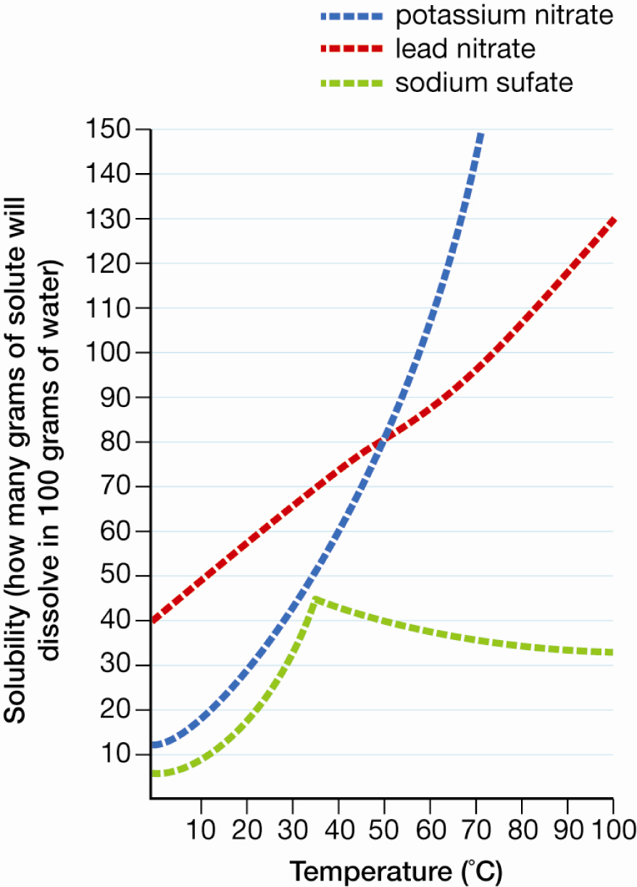  A Heating up to 35°C will work, but above that less of the solid will dissolve.  B Heating up to 100°C should work well because solubility increases with increasing temperature.  C Heating should work because at all temperatures above 20°C there is more of the solute in 100 g of water than there is at 20°`C.  D Heating will not work because less sodium sulfate dissolves at higher temperatures. | A | 1
 | Consider the following information about a solution:  Mass of solute  (g)  Volume of solvent  (mL)  Temperature  (°C)  Is solution saturated?  19  100  40  not saturated  20  100  40  saturated  7  100  20  not saturated  8  100  20  saturated  What is the most likely outcome if you cool the saturated liquid at 40°C down to 30°C?  A All of the solid would reappear and settle on the bottom of the container.  B 12 g of the solid would reappear in the liquid.  C Between 20 g and 12 g of the solid would reappear.  D 7 g of the solid would reappear | B | 1

